**home.html**

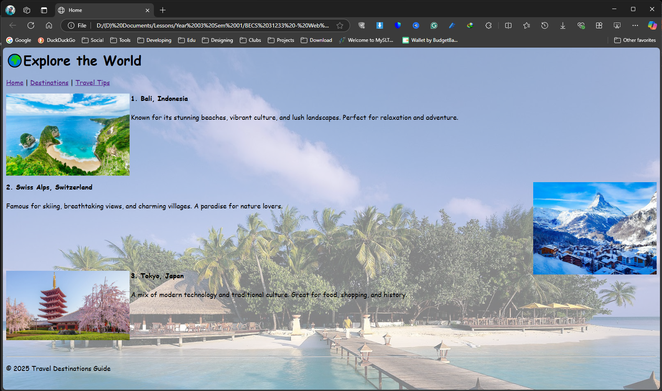

<html>

<head>

<title>Home</title>

</head>

<body background="home bg.png">

<font face="Comic Sans MS">

<h1>🌍Explore the World</h1>

<a href="home.html">Home</a> | <a href="home.html">Destinations</a> | <a href="home.html">Travel Tips<a>

<p>

<img src="bali beach.jpg" alt="Bali" width="300" align ="left">

<b>1. Bali, Indonesia</b><br><br>

Known for its stunning beaches, vibrant culture, and lush landscapes. Perfect for relaxation and adventure.<br>

</p><br><br><br><br><br>

<p>

<img src="swiss alps.jpeg" alt="Swiss Alps" width="300" align ="Right">

<b>2. Swiss Alps, Switzerland</b><br><br>

Famous for skiing, breathtaking views, and charming villages. A paradise for nature lovers.<br>

</p><br><br><br><br><br>

<p>

<img src="tokyo.jpg" alt="Tokyo" width="300" align ="left">

<b>3. Tokyo, Japan</b><br><br>

A mix of modern technology and traditional culture. Great for food, shopping, and history.<br>

</p><br><br><br><br><br>

<hr>

<p>© 2025 Travel Destinations Guide</p>

</body>

</html>

**destinations.html**

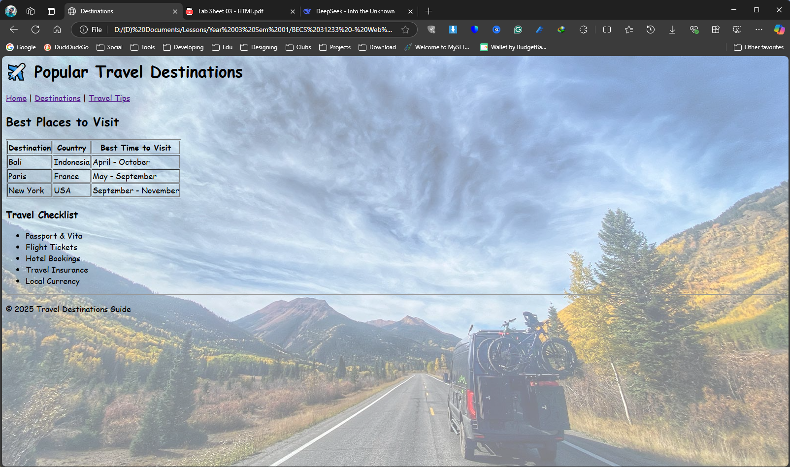

<html>

<head>

<title>Destinations</title>

</head>

<body background="destinations bg.png">

<font face="Comic Sans MS">

<h1>✈️ Popular Travel Destinations</h1>

<a href="home.html">Home</a> | <a href="destinations.html">Destinations</a> | <a href="tips.html">Travel Tips<a>

<h2>Best Places to Visit</h2>

<table border="1">

<tr>

<th>Destination</th>

<th>Country</th>

<th>Best Time to Visit</th>

</tr>

<tr>

<td>Bali</td>

<td>Indonesia</td>

<td>April - October</td>

</tr>

<tr>

<td>Paris</td>

<td>France</td>

<td>May - September</td>

</tr>

<tr>

<td>New York</td>

<td>USA</td>

<td>September - November</td>

</tr>

</table>

<h2>Travel Checklist</h2>

<ul>

<li>Passport & Vita</li>

<li>Flight Tickets</li>

<li>Hotel Bookings</li>

<li>Travel Insurance</li>

<li>Local Currency</li>

</ul>

<hr>

<p>© 2025 Travel Destinations Guide</p>

</body>

</html>

**tips.html**

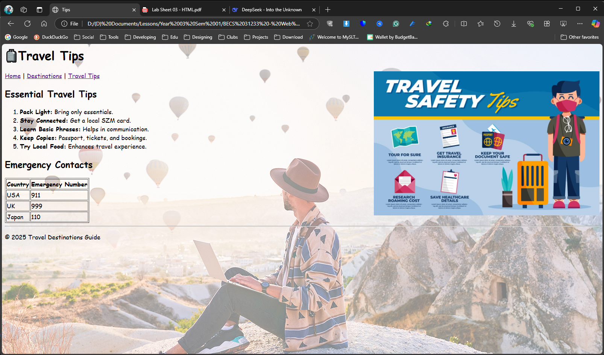

<html>

<head>

<title>Tips</title>

</head>

<body background="tips bg.png">

<font face="Comic Sans MS">

<h1>🧳Travel Tips</h1>

<a href="home.html">Home</a> | <a href="destinations.html">Destinations</a> | <a href="tips.html">Travel Tips<a>

<img src="travel tips.jpg" alt="travel tips" width="600" align ="Right">

<h2>Essential Travel Tips</h2>

<ol>

<li><strong>Pack Light:</strong> Bring only essentials.</li>

<li><strong>Stay Connected:</strong> Get a local SZM card.</li>

<li><strong>Learn Basic Phrases:</strong> Helps in communication.</li>

<li><strong>Keep Copies:</strong> Passport, tickets, and bookings.</li>

<li><strong>Try Local Food:</strong> Enhances travel experience.</li>

</ol>

<h2>Emergency Contacts</h2>

<table border="1">

<tr>

<th>Country</th>

<th>Emergency Number</th>

</tr>

<tr>

<td>USA</td>

<td>911</td>

</tr>

<tr>

<td>UK</td>

<td>999</td>

</tr>

<tr>

<td>Japan</td>

<td>110</td>

</tr>

</table>

<hr>

<p>© 2025 Travel Destinations Guide</p>

</body>

</html>